# **CISW410 Final Project – Spring 2019**

## **REVIEW: Chapter 16 | Ex 16-1, Ex 16-2**

### **Chapter 16 – Ex 16-1 – Screen Capture of Database Diagram**

In this exercise I was created new diagram within new model in MySQL Workbench from the script. Also, I checked Primary keys of the tables and added Foreign keys and relationships between six tables.

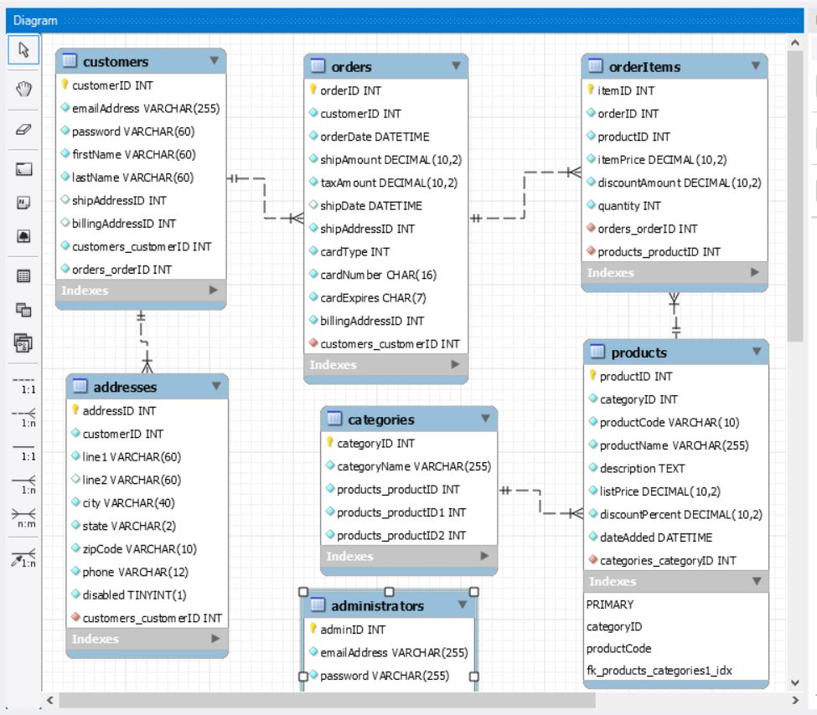

### **Chapter 16 – Ex 16-2 – Summary and Screen Capture of Database Diagram**

In Exercise 16-2 I was created small database of music albums created by music artists that contain three tables: Artists, Albums, Songs. They all have Primary keys and relate to each other. Each artist may have one or more albums, and each album may have one or more tracks (songs).

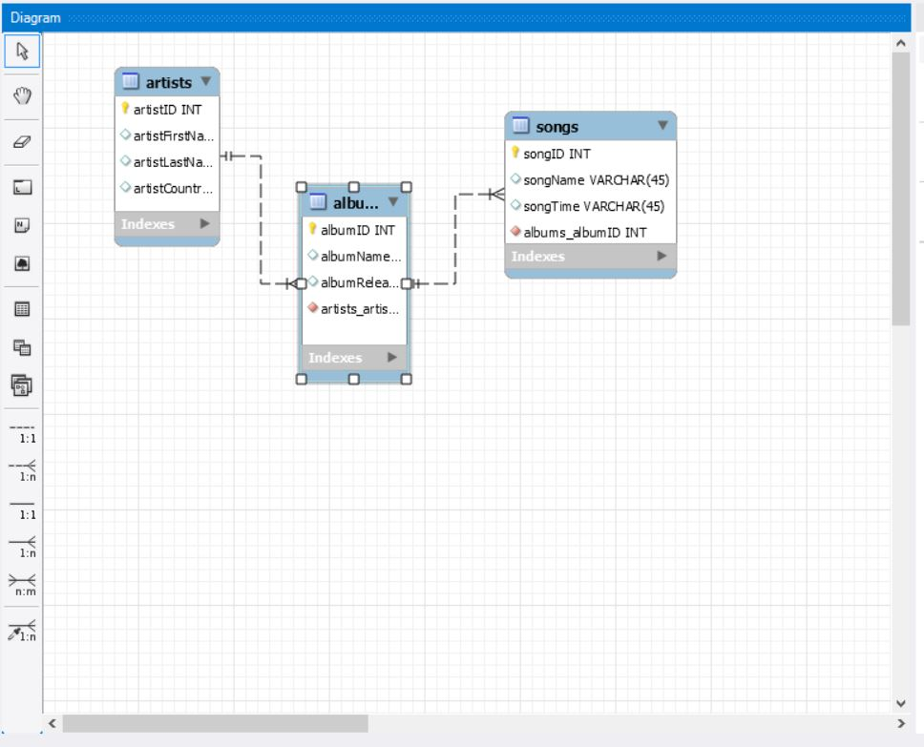

## **REVIEW: Chapter 17 | Ex 17-1, Ex 17-2**

### **Chapter 17 - Ex 17-1 – Summary of script and screen capture illustrating testing the script**

Here I was running a script that contains statement that alter that database. I created new script that added middleInitials to the Customer table and then modifies firstName column, so it can store up to 100 characters.



### **Chapter 17 - Ex 17-2 – Summary of script and screen captures illustrating testing the script**

In this xercise I created a simple database Accounts Payable (AP) that contains only 3 columns. Also, I added to the script file statements to create indexes and a user, and grant this user privileges to select, insert, or update data from any table in the database.

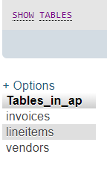 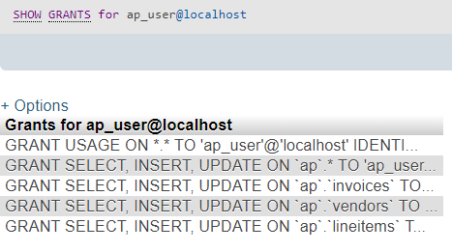

## **REVIEW: Chapter 18 | Ex 18-1**

### **Chapter 18 - Ex 18-1 – Work with data in a database**

SELECT statement retrieves data from one or more tables. To specify data we can use from, ordered by, where clauses. In this exercise I was practicing with some SELECT statements that retrieve data from different tables and columns and categorize it. For instance, the script that selects only three columns of the table and sortings the data by word “electric” and shows only selected rows. The another select statement selects data from two tables by last name of the customers “sherwood”. And the last select statement returns a count of the number of products in the category with a name of “Guitar”.

INSERT

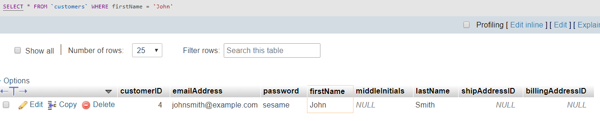

UPDATE

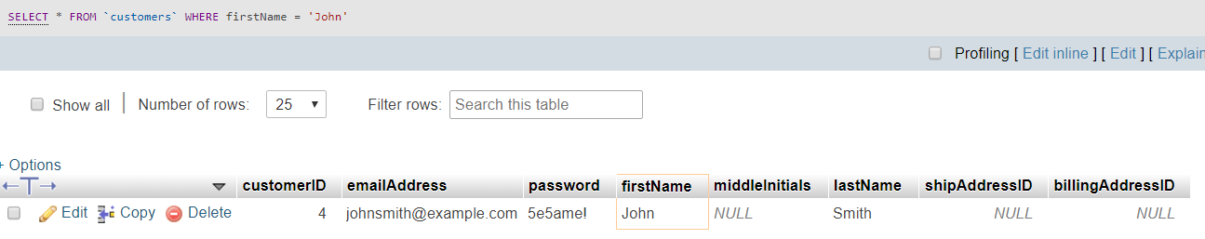

DELETE

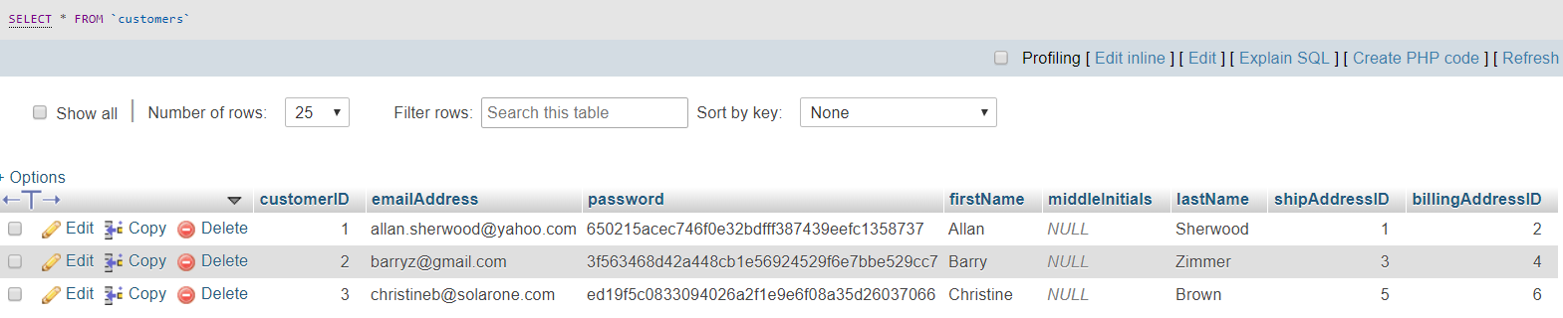

## **Chapter 19 | Ex 19-1**

### **Chapter 19 - Ex 19-1 – Use PHP to work with a database**

Functions use the prepared statements to make work with a database easier and faster. For exercise in this chapter I was modified code in two files, so that I was willing to add product to category Guitars. The other function get_product_by_name() using parameter name returns array of the product with a specific name of the category. Then this function was modified with delete_product statement that deleted product by its ID.

An output of the code

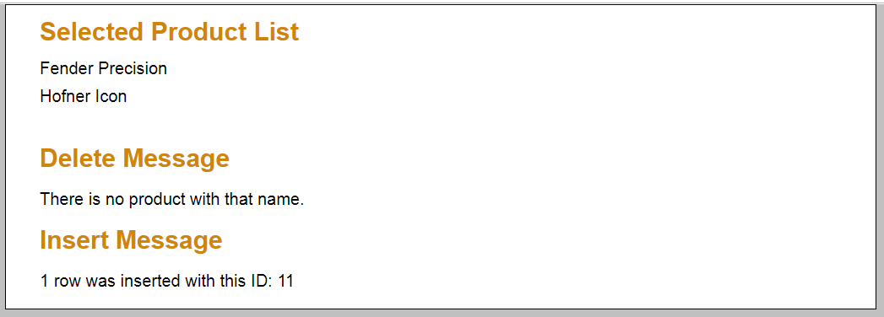

## **Chapter 20 | Ex 20-1**

### **Chapter 20 - Ex 20-1 – Enhance the Guitar Shop application**

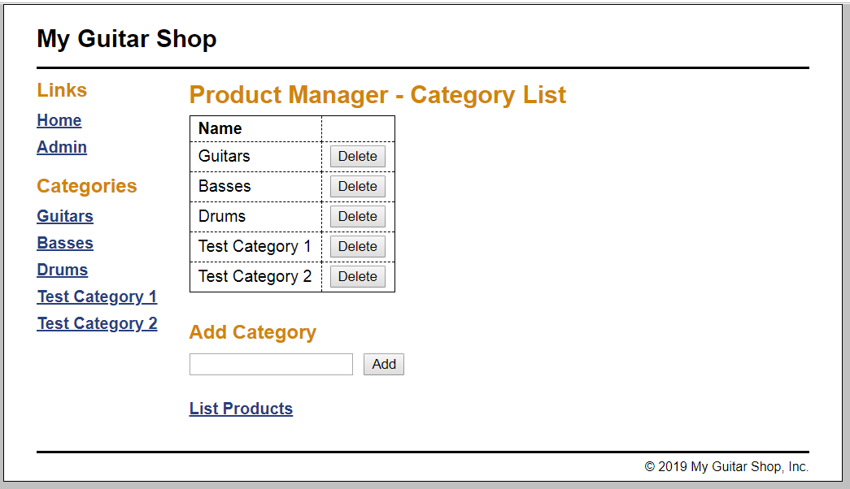

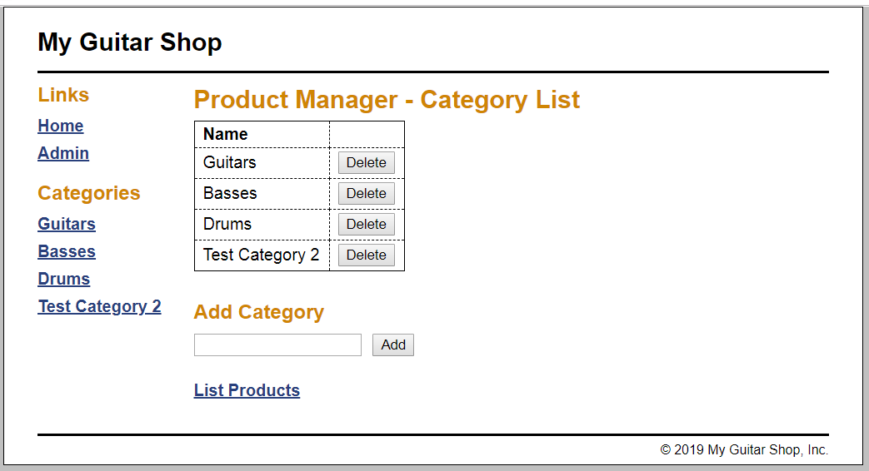

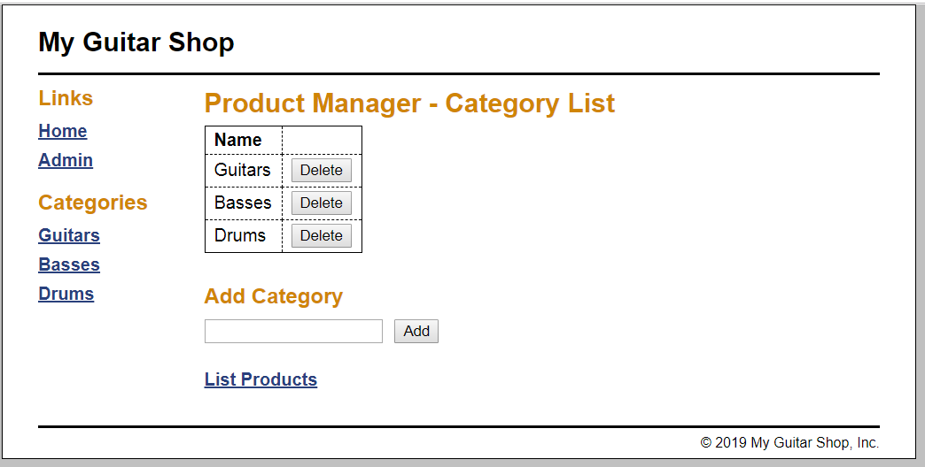

Here I edited three files and created one additional file. The screen captures displayed that first I added two products’ categories to the application: Test Category 1 and Test Category 2. Then, using the Delete button I deleted these two categories.

**ADD A FUNCTION (step 15 and step 16)**

In this part of the exercise I added get_product_count function in case when admin wants to delete category that contains data (products) so that displays warning message that this category can't be deleted. Also, I modified delete_category switch-case statement, so it displays message if category contains data. This part of code prevents accidentally deleted data and protects referential integrity, because all data is linked between tables.

